Potton Primary School
Maths Strategy Document
Intent
The intent of our teaching of Mathematics is to provide children with a foundation for understanding number, reasoning, thinking logically and problem solving with resilience so that they are fully prepared for the future. It is essential that these keystones of Mathematics are embedded throughout all strands of the National Curriculum. By adopting a mastery approach, it is also intended that all children, regardless of their starting point, will maximise their academic achievement and leave Potton Federation with an appreciation and enthusiasm for Maths, resulting in a lifelong positive relationship with number.
- We ensure that we deliver a high quality Maths curriculum that is both challenging and enjoyable.
- We want children to make rich connections across mathematical ideas to develop fluency, mathematical reasoning and competence in solving increasingly sophisticated problems.
- We intend for our pupils to be able to apply their mathematical knowledge to a range of other subjects.
- We want them to know that maths is essential to everyday life and that our children are confident mathematicians who are not afraid to take risks.
- Fully develop independent learners with inquisitive minds who have secure mathematical foundations and an interest in self-improvement.
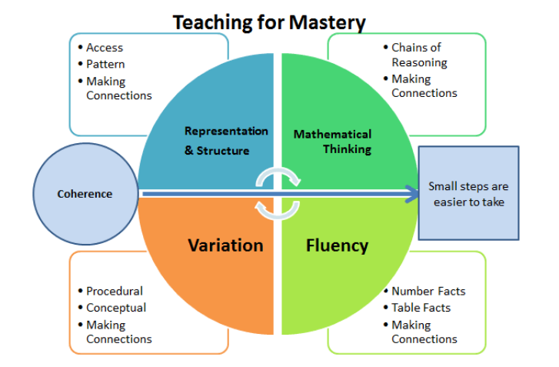
Implementation
At Potton Primary School, maths is taught daily following White Rose Maths scheme of learning. White Rose Maths (WRM) is structured to ensure every unit is taught in depth and built upon from the last. Every year group starts the year with place value, which is consistently referred back to in all units that follow. Teachers refer to the Calculation Policy, in which mathematical methods are explained and demonstrated to ensure consistency throughout our school.
Our Mastery Approach:
- Concrete, Pictorial, Abstract Learning. We begin with the concrete stage which is known as the ‘doing’ stage, using manipulatives and objects to solve maths problems. Pictorial is known as the ‘seeing’ stage in which, children draw/use pictures, diagrams and models to develop understanding from the concrete stage. We then move onto the abstract approach, which is the ‘symbolic’ stage, using a variety of symbols and numbers only. Using this approach is a vital part of maths mastery for all learners and is adopted across the school from reception to year 6.
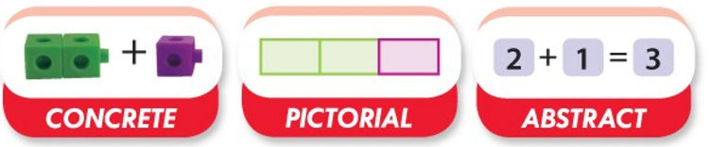
- Fluency, Reasoning and Problem Solving. Every lesson is designed to develop fluency, so children are always referring back to their wide range of mathematical skills. With fluent maths knowledge, the children can apply by reasoning and problem solving.
- Mathematical Vocabulary. Clear modelling and referencing of mathematical language is seen in every lesson. Stem sentences are adopted to support and encourage all children to communicate their ideas.
At Potton Primary School we are committed to teaching and practicing times table so when the children reach the end of year 4, they are confident and fluent with their times table and related division facts. We do this with the use of Times Table Rockstars, games, chants etc.
Impact
When our children leave Potton Primary School at the end of year 6, we aspire for them to leave as well equipped, inspired and fluent mathematicians with a deep understanding of all concepts we cover. Our mastery approach will enable children to:
- Develop confidence and belief as a mathematician.
- The knowledge and awareness that maths underpins our daily lives.
- Make connections and relationships between learning and consistently refer back to previous learning to build upon.
- Recall number facts promptly.
- Problem solve and reason effectively.
- Learn from mistakes and preserve to when challenges are set and arise.
- Collaborate with peers, show respects for others and their thinking.
- Understand that mistakes are part of the learning journey.
A mathematical concept or skill has been mastered when a child can show it in multiple ways, using the mathematical language to explain their ideas, and can independently apply the concept to new problems in unfamiliar situations and this is the goal for our children.

