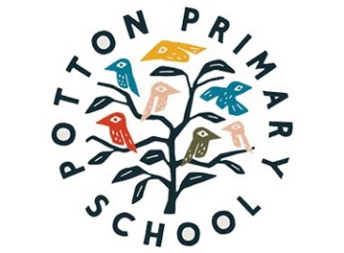

Potton Primary School
English Curriculum Impact Statement
We are ambitious for all our children and strive to ensure that we provide all children with the skills needed for them to become successful writers, no matter what their starting point, background or additional needs.
By the end of KS2 we expect our children to:
• Enjoy writing and view themselves as effective, competent writers;
• Have a good understanding of the purpose of writing and can write effectively for a range of purposes and audiences.
• Have a wide vocabulary that they use within their writing.
• Leave primary school being able to effectively apply spelling rules and patterns they have been taught.
We aim to meet the expectations of the Early Learning Goals and the National Curriculum and when possible, exceed these and ensure that children make good progress in Writing during their time at Potton Primary School.
Therefore, we aim to achieve:
• Outcomes at the end of KS1 in writing that are at least in line with or above national averages for attainment at both standards.
• Outcomes at the end of KS2 in writing that are at least in line with national or above averages for attainment at both standards and progress.
• The % of pupils working at Age Related Expectations in writing within each year group will be at least in line with national averages.
• The % of pupils working at Greater Depth in writing within each year group will be at least in line with national averages.

